**Project Planning Phase**

**Sprint Delivery Plan**

|  |  |
| --- | --- |
| Date | 26 October 2022 |
| Team ID | PNT2022TMID14537 |
| Project Name | Gas Leakage Monitoring and Alerting System for Industries |
| Maximum Marks | 8 Marks |

**Product Backlog, Sprint Schedule, and Estimation (4 Marks)**

|  |  |  |  |  |  |  |
| --- | --- | --- | --- | --- | --- | --- |
| **Sprint** | **Total Story Points** | **Duration** | **Sprint Start Date** | **Sprint End**  **Date**  **(Planned)** | **Story Points**  **Completed**  **(as on Planned**  **End Date)** | **Sprint Release Date (Actual)** |
| Sprint-1 | 20 | 6 Days | 24 Oct 2022 | 29 Oct 2022 | 20 | 29 Oct 2022 |
| Sprint-2 | 20 | 6 Days | 31 Oct 2022 | 05 Nov 2022 | 20 | 05 Nov 2022 |
| Sprint-3 | 20 | 6 Days | 07 Nov 2022 | 12 Nov 2022 | 20 | 12 Nov 2022 |
| Sprint-4 | 20 | 6 Days | 14 Nov 2022 | 19 Nov 2022 | 20 | 19 Nov 2022 |

|  |  |  |  |  |  |  |
| --- | --- | --- | --- | --- | --- | --- |
| **Sprint** | **Functional**  **Requirement (Epic)** | **User**  **Story**  **Number** | **User Story / Task** | **Story Points** | **Priority** | **Team Members** |
| Sprint-1 | Analyzing the gas leakage | USN-1 | The owner who wants to save his employees or a person who wants to save their family from explosion takes necessary actions | 2 | High | Faraaz Ahmed C  Mohammed Affan C  Mohamed Arqam  Abdullah M  Abdur Rahman  Hammad NS |
| Sprint-1 | Preventing from explosion | USN-2 | The fire officers worries about any explosions due to gas leakage which may cause many death | 1 | High | Mohamed Arqam  Abdullah M  Abdur Rahman Hammad  NS  Aasim Ahmed M  Harun J |
| Sprint-2 | To detect the gas leakage | USN-3 | The owner can take necessary steps by deploying gas detectors in their surroundings | 2 | Low | Aasim Ahmed M  Harun J  Faraaz Ahmed C  Mohammed Affan C |
| Sprint-3 | Testing and training of the model device | USN-4 | The programmer can design an gas leakage detection model by training the dataset | 2 | Medium | Mohammed Affan C  Mohamed Arqam  Abdullah M  Aasim Ahmed M  Abdur Rahman Hammad  NS |
| Sprint-4 | Notification | USN-5 | The gas leakage detected by the model can be notified using SMS or alarming system | 1 | High | Harun J  Faraaz Ahmed C  Mohammed Affan C  Aasim Ahmed M |

**Project Tracker, Velocity & Burndown Chart: (4 Marks) Velocity:**

Imagine we have a 10-day sprint duration, and the velocity of the team is 20 (points per sprint). Let’s calculate the team’s average velocity (AV) per iteration unit (story points per day)

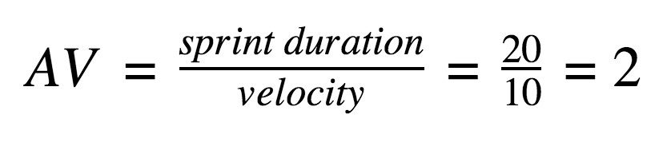

**Burndown Chart:**

A burn down chart is a graphical representation of work left to do versus time. It is often used in agile software development methodologies such as Scrum. However, burn down charts can be applied to any project containing measurable progress over time.

GAS LEAKAGE MONITORING AND ALERTING SYSTEM FOR INDUSTRIES

